Name Tag
- Write your name in the middle of your paper.
- Make sure it is dark so others can see your name. Write the name you want others to call you.

- Add some fun pictures and colour.

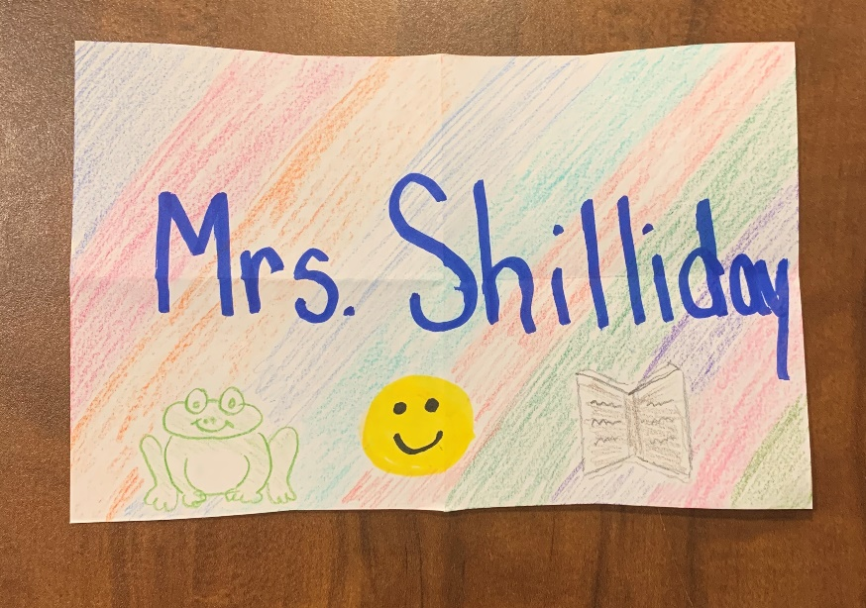
- Remember to bring nametag with you for our Teams morning meeting.

